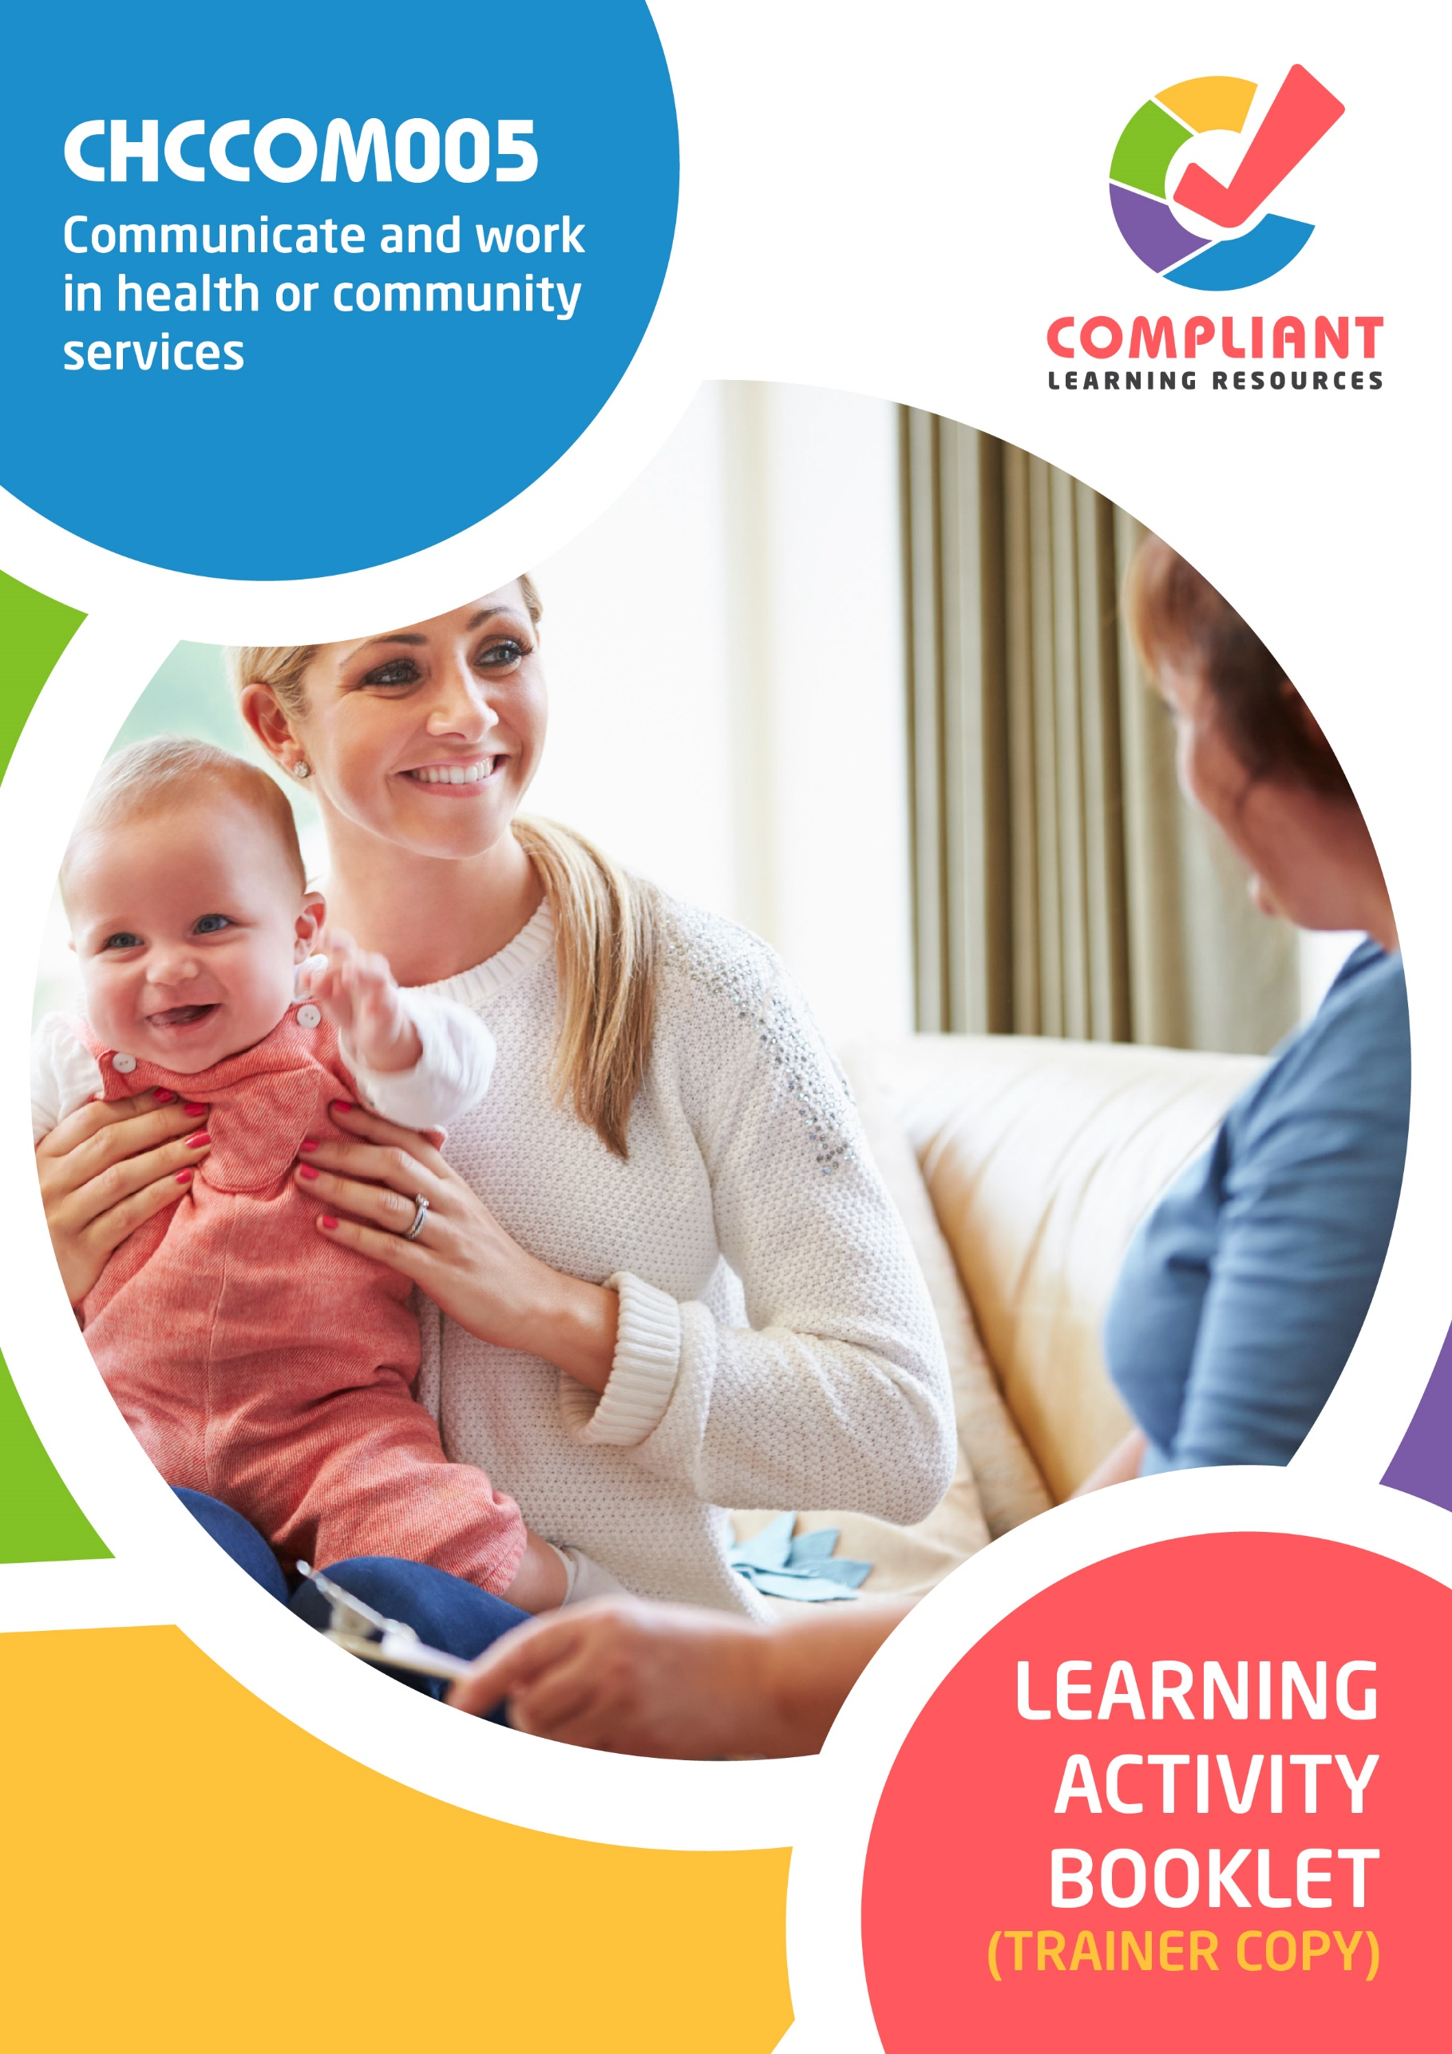

**Copyright**

This document was developed by Compliant Learning Resources.

© 2022 Compliant Learning Resources.

All rights reserved.

No part of this publication may be reproduced, stored in a retrieval system, or transmitted in any form or by any means, electronic, mechanical, photocopying, recording, or otherwise without the prior written permission of Compliant Learning Resources.

**Version Control & Document History**

|  |  |  |
| --- | --- | --- |
| **Date** | **Summary of Modifications** | **Version** |
| 8 June 2022 | Version 1.0 released for publishing | 1.0 |

# Table of Contents

Overview 4

Trainer Instructions 5

Learner Instructions 6

Learner Information 6

Trainer Information 6

Resources Required 7

Work Health and Safety 7

Reasonable Adjustment 8

Contextualisation 9

Formative Activities 10

I. Communicate Effectively With People 10

Activity 1.1 10

Activity 1.2 11

II. Collaborate With Colleagues 12

Activity 2.1 12

Activity 2.2 13

III. Address Constraints to Communication 14

Activity 3.1 14

Activity 3.2 15

IV. Report Conflicts 16

Activity 4.1 16

Activity 4.2 17

V. Accomplish Workplace Correspondence and Documentations 18

Activity 5.1 18

Activity 5.2 19

VI. Contribute to Continuous Improvement 20

Activity 6.1 20

Activity 6.2 21

# Overview

**CHCCOM005 - Communicate and work in health or community services (Release 2)**

This unit describes the skills and knowledge required to communicate effectively with clients, colleagues, management and other industry providers.

This unit applies to a range of health and community service contexts where workers may communicate face-to-face, in writing or using digital media and work with limited responsibility under direct or indirect supervision.

The skills in this unit must be applied in accordance with Commonwealth and State/Territory legislation, Australian/New Zealand standards and industry codes of practice.

**A complete copy of the above unit of competency can be downloaded from the TGA website:**

<https://training.gov.au/training/details/CHCCOM005>

# Trainer Instructions

This Learning Activity Booklet contains formative activities that learners will complete in the classroom or a similar environment.

These formative activities include knowledge questions to test learners’ underpinning generic knowledge and practical activities to test their skills relevant to the unit/s of competency.

These formative assessments are used by trainers to complement both the learning and training processes, and to evaluate how learners are progressing throughout these processes.

**IMPORTANT:**

**The completion of the formative assessments and learning activities included in this workbook DOES NOT lead to a Qualification or a Statement of Attainment (SOA).**

Reasonable adjustment applies here, and while the majority of learners will complete this assessment as a written assessment, verbal assessment may be an option for those who need it. The assessor must use the marking guide as the principal marking tool unless a reasonable adjustment is demonstrated.

The Learning Activity Booklet (Trainer Copy) provides model answers to all the questions, setting out which key responses must be included as well as indicating where flexibility is acceptable.

The number of responses required is specified in each assessment task to avoid ambiguity. In these cases, the model answer will provide a list of possible answers. For instance, if a question requires the learner to list three examples, then their response must include three of the items listed in the model answer.

# Learner Instructions

This Learning Activity Booklet contains formative activities that learners will complete in the classroom or a similar environment.

These formative activities include knowledge questions to test your underpinning generic knowledge and practical activities to test your skills relevant to the unit/s of competency.

These formative assessments are used by your trainer to complement both the learning and training processes, and to evaluate how you are progressing throughout these processes.

You may reference your Learner Guide and other learning materials to complete the activities included in this workbook.

**IMPORTANT:**

**The completion of the formative assessments and learning activities included in this workbook DOES NOT lead to a Qualification or a Statement of Attainment (SOA).**

## Learner Information

|  |  |
| --- | --- |
| Learner name |  |
| Phone |  |
| Email |  |

## Trainer Information

|  |  |
| --- | --- |
| Trainer name |  |
| RTO name |  |
| RTO phone |  |
| RTO email |  |

# Resources Required

Resources needed to complete activities included in this workbook include:

* Computer with Internet, email access, and a working web browser
* Installed software: MS Word, Adobe Acrobat Reader
* Learner guide

# Work Health and Safety

Both the trainers and learners have a duty of care in ensuring that the learning environment is free from hazards that may pose risks to their health and safety.

According to WHS legislation, trainers and learners must take reasonable care while undertaking the activities included in this workbook in the learning environment.

# Reasonable Adjustment

‘Reasonable adjustment’ in VET is the term applied to modifying the learning environment or making changes to the training delivered to assist a learner with a disability. A reasonable adjustment can be as simple as changing classrooms to be closer to amenities or installing a particular type of software on a computer for a person with vision impairment.

**Why make a reasonable adjustment?**

We make reasonable adjustments in VET to make sure that learners with disabilities have:

* The same learning opportunities as learners without disabilities, and
* The same opportunity to perform and complete assessments as those without disabilities.

**Reasonable adjustment applied to participation in teaching, learning, and assessment activities can include:**

* Customising resources and assessment activities within the training package or accredited course
* Modifying the presentation medium
* Learner support
* Use of assistive/adaptive technologies
* Making information accessible both before enrolment and during the course
* Monitoring the adjustments to ensure learner needs continue to be met

**Assistive/Adaptive Technologies**

Assistive/adaptive technology means ‘software or hardware that has been specifically designed to assist people with disabilities in carrying out daily activities’ (World Wide Web Consortium - W3C). It includes screen readers, magnifiers, voice recognition software, alternative keyboards, devices for grasping, visual alert systems, and digital note-takers.

*(Adapted Reasonable Adjustment in teaching, learning and assessment for learners with a disability - November 2010 - Prepared by - Queensland VET Development Centre)*

**IMPORTANT:**

**Reasonable adjustment made for collecting learner assessment evidence must not impact the standard expected by the workplace, as expressed by the relevant unit/s of competency. For example, if the assessment were gathering evidence of the learner’s competency in writing, allowing the learner to complete the assessment verbally would not be a valid assessment method. The method of assessment used by any reasonable adjustment must still meet the competency requirements.**

# Contextualisation

Contextualisation is the process of modifying assessment tools to make learning more meaningful for your students and their employers.

Compliant Learning Resources highly recommends that your RTO contextualise the assessment tools before using them.

You must contextualise the assessment tools to suit:

* Your student’s needs
* Your RTO’s training and assessment processes
* The work and industry context in which you operate

**Contextualising for your state/territory**

The contents of this assessment tool are not written for a specific state/territory unless stated otherwise. Where the assessment tool refers to legislation and other industry requirements, which may vary across states/territories, model answers are based on one state/territory.

Should your RTO intend to use this assessment tool for learners from your state/territory, Compliant Learning Resources recommends you to:

* Access and review the legislation and industry requirements applicable in your state/territory.
* Update assessments and benchmark answers to reflect the legislation and industry requirements applicable in your state/territory.

When you are contextualising assessment tools, you must ensure that you retain the integrity of the assessment and the outcomes of the unit of competency.

**A comprehensive guide to contextualising your assessment tools for your RTO can be accessed through this link:**

<https://compliantlearningresources.com.au/blog/simple-guide-to-contextualising-rto-training-resources-and-assessment-tools/>

# Formative Activities

## I. Communicate Effectively With People

### Activity 1.1

|  |  |
| --- | --- |
| **True or False**  Review the statements below about communicating with relevant people in health or community services. Indicate whether each statement is True or False.  Tick the box that corresponds to your answer. | |
|  | |
| *Mapping: CHCCOM005 PC1.1 (p), PC1.3 (p), PC1.4 (p)*  *Learner guide reference: CHCCOM005 Learner Guide, Chapter 1, Subchapter 1.1, Section 1.1.1, Section 1.1.2, Subchapter 1.3, Subchapter 1.4, Section 1.4.3* | |
| TRUE  FALSE | 1. Understanding refers to the ability of a person to comprehend and realise people or situations. |
| TRUE  FALSE | 1. Grammar patterns are vital structures for messages and information to carry meaning. |
| TRUE  FALSE | 1. Restating the idea is one way to confirm a person’s understanding. |
| TRUE  FALSE | 1. Responses must be complex when talking to people whose first language is not English. |
| TRUE  FALSE | 1. It is advisable to use jargon when talking to clients. |

### Activity 1.2

|  |
| --- |
| Identify five types of digital media that may be used when sharing service information with the public. |
|  |
| *Mapping: CHCCOM005 PC1.2 (p)*  *Learner guide reference: CHCCOM005 Learner Guide, Chapter 1, Subchapter 1.2, Section 1.2.2*  **Marking Guide**  The learner must identify five types of digital media that may be used when sharing service information with the public.  For satisfactory performance, although the wording and order may slightly vary, their response must be five of the following:   * Web * Email * Social media * Podcasts * Videos * Tablets * Applications * Newsletters * Broadcasts * Intranet |
|  |
|  |
|  |
|  |
|  |

## II. Collaborate With Colleagues

### Activity 2.1

|  |  |
| --- | --- |
| **True or False**  Review the statements below about timeframes and lines of communication. Indicate whether each statement is True or False.  Tick the box that corresponds to your answer. | |
|  | |
| *Mapping: CHCCOM005 PC2.1 (p), PC2.2 (p)*  *Learner guide reference: CHCCOM005 Learner Guide, Chapter 2, Subchapter 2.1, Section 2.1.2, Subchapter 2.2* | |
| TRUE  FALSE | 1. Timeframe refers to a particular period in which a task needs to be accomplished. |
| TRUE  FALSE | 1. Setting timeframes help in preventing missed or delayed deadlines. |
| TRUE  FALSE | 1. It is important to wait for somebody else to voice out when a certain concern needs to be addressed immediately. |
| TRUE  FALSE | 1. Managers have the same roles as supervisors. |
| TRUE  FALSE | 1. Clients coordinate with allied health professionals regarding their multiple needs. |

### Activity 2.2

|  |
| --- |
| Identify three components that a communication protocol usually contains. |
|  |
| *Mapping: CHCCOM005 PC2.4 (p)*  *Learner guide reference: CHCCOM005 Learner Guide, Chapter 2, Subchapter 2.4, Section 2.4.2*  **Marking Guide**  The learner must identify three components that a communication protocol may contain.  For satisfactory performance, although the wording and order may slightly vary, their response must be three of the following:   * Information * Person responsible * Venue * Audience * Frequency |
|  |
|  |
|  |

## III. Address Constraints to Communication

### Activity 3.1

|  |  |
| --- | --- |
| **True or False**  Review the statements below about communication strategies and techniques that may be used in resolving communication conflicts. Indicate whether each statement is True or False.  Tick the box that corresponds to your answer. | |
|  | |
| *Mapping: CHCCOM005 PC3.2 (p)*  *Learner guide reference: CHCCOM005 Learner Guide, Chapter 3, Subchapter 3.2, Section 3.2.2* | |
| TRUE  FALSE | 1. Reflections refer to positive statements that can help in conquering negativities. |
| TRUE  FALSE | 1. Mirroring refers to the form of reflecting that involves repeating what has been said. |
| TRUE  FALSE | 1. Summarising refers to coming up with a brief outline of the necessary points from a conversation, meeting, or workplace document. |
| TRUE  FALSE | 1. Coercive approach refers to an approach used to help people manage uncertain feelings and insecurities. |
| TRUE  FALSE | 1. Collaboration is an approach that is concerned with both parties in a conversation. |

### Activity 3.2

|  |
| --- |
| Identify three communication skills that can be used to avoid, defuse and resolve communication conflicts in the workplace. |
|  |
| *Mapping: CHCCOM005 PC3.3 (p)*  *Learner guide reference: CHCCOM005 Learner Guide, Chapter 3, Subchapter 3.3*  **Marking Guide**  The learner must identify three communication skills that can be used to avoid, defuse and resolve communication conflicts in the workplace.  Responses may vary. However, for satisfactory performance, their response must be three communication skills that can be used to avoid, defuse and resolve communication conflicts in the workplace. Examples of satisfactory responses include the following:   * Active listening * Clarity * Confidence * Empathy * Kindness * Open-mindedness |
|  |
|  |
|  |

## IV. Report Conflicts

### Activity 4.1

|  |  |
| --- | --- |
| **True or False**  Review the statements below about referring breach or adverse events to relevant people. Indicate whether each statement is True or False.  Tick the box that corresponds to your answer. | |
|  | |
| *Mapping: CHCCOM005 PC4.2 (p)*  *Learner guide reference: CHCCOM005 Learner Guide, Chapter 4, Subchapter 4.2, Section 4.2.1, Section 4.2.2* | |
| TRUE  FALSE | 1. Adverse event refers to practices that are deemed non-compliant based on legal and ethical requirements. |
| TRUE  FALSE | 1. Breaches refer to an unexpected problem that occurs during medical treatment. |
| TRUE  FALSE | 1. Medical devices are one of the three main categories that fall under therapeutic goods. |
| TRUE  FALSE | 1. Near misses refer to incidents that might have led to a serious injury or death. |
| TRUE  FALSE | 1. Supervisors can help in addressing breaches or adverse events by coordinating with regulatory authorities. |

### Activity 4.2

|  |
| --- |
| Identify three possibilities or consequences of having unresolved conflicts in the workplace. |
|  |
| *Mapping: CHCCOM005 PC4.4 (p)*  *Learner guide reference: CHCCOM005 Learner Guide, Chapter 4, Subchapter 4.4, Section 4.4.1*  **Marking Guide**  The learner must identify three possibilities or consequences of having unresolved conflicts in the workplace.  Responses may vary. However, for satisfactory performance, their response must be three possibilities or consequences of having unresolved conflicts in the workplace. Examples of satisfactory responses include the following:   * The number of complaints may increase. * Lapses in communication may worsen. * Deadlines may be delayed or missed. * Employee turnover may increase. * Collaboration may be reduced. * Members may become unmotivated. * Clients may stop subscribing to services. * Work culture may become toxic. |
|  |
|  |
|  |

## V. Accomplish Workplace Correspondence and Documentations

### Activity 5.1

|  |  |
| --- | --- |
| **True or False**  Review the statements below about role-related workplace documents and documenting events using clear, accurate and objective language. Indicate whether each statement is True or False.  Tick the box that corresponds to your answer. | |
|  | |
| *Mapping: CHCCOM005 PC5.2 (p), PC5.5 (p)*  *Learner guide reference: CHCCOM005 Learner Guide, Chapter 5, Subchapter 5.2, Section 5.2.1, Subchapter 5.5, Section 5.5.2* | |
| TRUE  FALSE | 1. Contracts refer to a documented agreement between two or more parties. |
| TRUE  FALSE | 1. Having the knowledge of the client and their medical history will help provide the necessary service. |
| TRUE  FALSE | 1. When documenting events, industry terminologies must be used consistently. |
| TRUE  FALSE | 1. Judgments and opinions are considered when documenting events. |
| TRUE  FALSE | 1. When documenting events, there must be a timeframe on when and how the event took place. |

### Activity 5.2

|  |
| --- |
| Identify the five components that must be included in reports when documenting events. |
|  |
| *Mapping: CHCCOM005 PC5.5 (p)*  *Learner guide reference: CHCCOM005 Learner Guide, Chapter 5, Subchapter 5.5, Section 5.5.1*  **Marking Guide**  The learner must identify the five components that must be included in reports when documenting events.  For satisfactory performance, although the wording and order may slightly vary, their response must be all the following:   * Person/s involved * Date and time * Location * Observations * Possible cause |
|  |
|  |
|  |
|  |
|  |

## VI. Contribute to Continuous Improvement

### Activity 6.1

|  |  |
| --- | --- |
| **True or False**  Review the statements below about improvements in work practices. Indicate whether each statement is True or False.  Tick the box that corresponds to your answer. | |
|  | |
| *Mapping: CHCCOM005 PC6.1 (p), PC6.2 (p)*  *Learner guide reference: CHCCOM005 Learner Guide, Chapter 6, Subchapter 6.1, Section 6.1.2, Subchapter 6.2, Section 6.2.2* | |
| TRUE  FALSE | 1. To contribute to continuous improvement, it is necessary to promote the value of creativity, innovation, and sustainability and recognise successes in the workplace. |
| TRUE  FALSE | 1. Improvements in work practices may be voiced out through surveys and feedback. |
| TRUE  FALSE | 1. Modelling improved work practices means supporting and encouraging other members of the service to do the same. |
| TRUE  FALSE | 1. Encouraging a sense of urgency when a matter needs to be cascaded immediately can help enhance communication. |
| TRUE  FALSE | 1. Feedback from previous and current clients must be reflected in the practices to increase client satisfaction. |

### Activity 6.2

|  |
| --- |
| Identify three options for accessing skill development opportunities. |
|  |
| *Mapping: CHCCOM005 PC6.4 (p)*  *Learner guide reference: CHCCOM005 Learner Guide, Chapter 6. Subchapter 6.4, Section 6.4.1*  **Marking Guide**  The learner must identify three options for accessing skill development opportunities.  For satisfactory performance, although the wording and order may slightly vary, their response must be three of the following:   * Training * Mentoring * Continuing Education * Seminar / Webinar * Membership in Organisations |
|  |
|  |
|  |

End of Document